### **6. Policy-Oriented Summary**

> "Write a brief summary about the youth of India focusing on government programs, schemes, and policies aimed at empowering young people."

•Sonar-
The youth of India, constituting about 65% of the population under 35, are a vital demographic for the nation's development. The government has launched numerous programs and policies to empower young people through skill development, education, entrepreneurship, health, and leadership opportunities. Key initiatives include Mera Yuva Bharat, a digital platform launched in 2023 to connect youth with volunteering, learning, and leadership projects across sectors; the Skill India Mission and Pradhan Mantri Kaushal Vikas Yojana (PMKVY), which provide industry-relevant skill training; and campaigns like Digital India that improve digital access and literacy[1][2][6]. Programs such as Startup India and Make in India incentivize youth entrepreneurship, while employment schemes like Rozgar Mela distribute job opportunities and financial aid like MUDRA Yojana facilitate small business loans[3][5][8].
The National Youth Policy (NYP) 2021 outlines a 10-year vision focusing on youth health, education, skill building, entrepreneurship, and leadership development, along with promoting sports and fitness through schemes like Khelo India and Target Olympic Podium Scheme (TOPS)[2][4][5]. Additional government efforts include empowerment schemes targeting minority youth, scholarships, and public engagement platforms like the National Youth Festival and Agnipath scheme, which foster civic participation and leadership[5][8].
Together, these programs aim to harness the potential of India’s youth, preparing them for future leadership and nation-building roles, while addressing skills gaps, employment challenges, and social inclusion to realize the country’s vision of a developed India by 2047[1][2][5].
•2.5 Flash Lite-
The Indian government has implemented a multifaceted approach to empower its youth through various schemes, policies, and programs. These initiatives are designed to foster skill development, promote entrepreneurship, enhance educational opportunities, and encourage participation in nation-building.
Key government initiatives focus on skilling and employability. The Pradhan Mantri Kaushal Vikas Yojana (PMKVY) is a flagship program aimed at enabling and mobilizing a large number of Indian youth to undertake outcome-based skill training, making them employable and self-sufficient. Additionally, the Deen Dayal Upadhyaya Grameen Kaushalya Yojana (DDU-GKY) specifically targets rural youth, providing them with skills and employment opportunities with regular monthly wages. The government also supports the upgradation of Industrial Training Institutes (ITIs) through initiatives like PM-SETU.
Entrepreneurship is another significant area of focus. Schemes such as Startup India and the Prime Minister's New Entrepreneurs Development Scheme encourage innovation and business creation among young people. The PM Mudra Yojana has been instrumental in fostering a culture of entrepreneurship by providing financial assistance for small-scale enterprises and startups.
Educational and holistic development is also prioritized. The National Youth Policy, with a draft for NYP 2024 building upon the NYP 2014, aims to create a supportive environment for youth. The National Service Scheme (NSS) and the National Youth Corps (NYC) are volunteer schemes designed to engage disciplined and dedicated youth in nation-building activities. Furthermore, initiatives like the Adolescence Education Programme aim to equip young people with accurate information and promote healthy attitudes.
The Ministry of Youth Affairs and Sports plays a central role in these efforts, overseeing various programs and institutions like the Sports Authority of India and the Rajiv Gandhi National Institute of Youth Development. The MY Bharat initiative aims to empower Indian youth through social mobility, educational equity, and practical skills. Recent governmental efforts also include unveiling youth-focused initiatives worth significant amounts, such as over Rs. 62,000 crore announced for various youth skilling and entrepreneurial endeavors.
- Ministry of Youth Affairs and Sports (yas.gov.in): This is the primary government body responsible for youth-related policies and programs in India. Its website provides information on various schemes, initiatives, and institutions dedicated to youth development, sports, and nation-building activities.
- National Youth Policy (NYP) Draft 2024 (pib.gov.in): This reference indicates the government's commitment to reviewing and updating its youth policies, with the draft of the new NYP 2024 outlining future directions for youth empowerment.
- Pradhan Mantri Kaushal Vikas Yojana (PMKVY) (india.gov.in): This is a key skill training scheme designed to enhance the employability of Indian youth by providing outcome-based skill development and certification.
- Startup India (pmwelfareschemetn.in): This initiative aims to foster entrepreneurship and innovation among youth by providing support and resources for new businesses and startups.
- National Youth Corps (myscheme.gov.in): This volunteer scheme by the Ministry of Youth Affairs and Sports mobilizes disciplined youth for nation-building activities.
•GPT-5 Nano-
India’s youth strategy is broad, multi-institutional, and continuously evolving to equip young people with skills, opportunities, and leadership roles. The backbone is a National Youth Policy framework that has guided reforms since 2014, with ongoing updates reflected in a draft National Youth Policy (NYP) 2024 and references to NYP 2023-32. Public input is being sought (NYP Draft 2024) to align policy with changing demographics and labor markets. This policy evolution signals a shift toward more outcome-focused youth development, entrepreneurship, and civic participation.
Key government programs and schemes span four core areas:
- Skill development and employment: flagship schemes like Prime Minister’s Youth Career Development Scheme (PMKVY) and broader entrepreneurship and credit supports (Startup India, Fund of Funds for Startups, PM Mudra) are designed to boost employability and self-employment. Government messaging highlights substantial investment in youth skilling and entrepreneurship, including training under ITIs. Official sources detail these schemes and their scale.
- National youth volunteering and civic empowerment: National Youth Corps (NYC) consolidates earlier volunteer schemes and sits alongside the National Service Scheme (NSS) and Nehru Yuva Kendra Sangathan (NYKS), aiming to channel youth energy into nation-building, community service, and leadership development. NYC and NYKS materials outline objectives, governance, and beneficiary groups.
- Youth leadership, education, and adolescent development: Programs like National Young Leaders Programme (NYLP) and National Programme for Youth and Adolescent Development (NPYAD) focus on leadership, clubs, and adolescence-friendly education. Policy and scheme documents describe target ages, activities, and expected outcomes.
- Sports, health, and holistic development: The Ministry of Youth Affairs and Sports champions initiatives such as Khelo India, the Sports Authority of India (SAI), and related institutions (RGNIYD, National Sports University) to promote fitness, discipline, and youth talent. Publicly available “New Initiatives” and department pages outline ongoing programs and investments in youth health and sport as part of overall empowerment.
In addition, government communications cite substantial annual investments in youth initiatives and emphasize inclusive programs across rural and urban youth, with data portals and policy pages tracking progress and impact.
- National Youth Policy updates and public engagement (NYP Draft 2024, NYP 2023-32) explain the policy direction and avenues for citizen input.
- Major schemes and schemes for youth (PMKVY, Startup India, PM Welfare schemes) describe the employment- and entrepreneurship-oriented components.
- NYC, NYKS, NSS, and NYLP illustrate the institutional framework for youth volunteering, leadership, and civic participation.
- Data and monitoring (NYPAD, NYLP data, department portals) provide program visibility and accountability.
References (selected, with relevance):
- National Youth Day 2025 - PIB: https://www.pib.gov.in/Pressreleaseshare.aspx?PRID=2092084 — Official update on NYP-related policies and youth initiatives.
- PM to unveil various youth-focused initiatives worth more than Rs 62,000 crore on 4th October - PM India: https://www.pmindia.gov.in/en/news_updates/pm-to-unveil-various-youth-focused-initiatives-worth-more-than-rs-62000-crore-on-4th-october/ — Government’s framing of large-scale youth-focused programs.
- National Youth Corps | Government of India (MYAS): https://yas.nic.in/youth-affairs/national-youth-corps — Core NYC framework and links to related youth programs.
- Inviting Suggestions for National Youth Policy (NYP) Draft 2024 - MyGov: https://www.mygov.in/task/inviting-suggestions-national-youth-policy-nyp-draft-2024/ — Public engagement in NYP modernization.
- National Programme for Youth and Adolescent Development (NPYAD) Guidelines - NYKS: https://nyks.nic.in/schemes/NPYAD-Guidelines.pdf — Details of a key adolescent/youth development program.
- New Initiatives | Ministry of Youth Affairs and Sports: https://yas.nic.in/youth/new-initiatives — Current youth-focused initiatives and investments.
- Schemes for Youth – PM Welfare Scheme: https://pmwelfareschemetn.in/en/schemes-for-youth/ — Compilation of youth-centric schemes (skill, entrepreneurship, welfare).
- Employment Schemes (eShram): https://eshram.gov.in/employment-schemes — Government employment and skilling schemes relevant to youth.
•Grok 4 Fast-
Youth in India: Government Programs, Schemes, and Policies for Empowerment
India's youth population, aged 15-29, constitutes about 27% of the total populace as per recent statistics (Youth in India-2022 report), representing a demographic dividend crucial for national development. The government has prioritized youth empowerment through skill development, employment generation, sports, volunteering, and policy frameworks to channel this energy productively. Key initiatives focus on education, entrepreneurship, health, and civic engagement, aligning with sustainable development goals.
The cornerstone is the National Youth Policy (NYP). The NYP-2014 emphasized holistic development, but it has been reviewed and updated, with a draft NYP-2024 released for public consultation. This new policy outlines strategies for youth participation in governance, skill enhancement, and social inclusion, aiming to address challenges like unemployment and mental health.
Major schemes under the Rashtriya Yuva Sashaktikaran Karyakram (RYSK) include:
- Nehru Yuva Kendra Sangathan (NYKS): Promotes rural youth development through awareness and leadership programs.
- National Youth Corps (NYC): Amalgamates volunteer schemes like National Service Volunteers (NSV) and Rashriya Sadbhavna Yojana (RSY), engaging over 1 million youth annually in community service, disaster relief, and social harmony.
- National Programme for Youth and Adolescent Development (NPYAD): Focuses on life skills, substance abuse prevention, and gender sensitization.
In skill development and employment, the Pradhan Mantri Kaushal Vikas Yojana (PMKVY) under the Ministry of Skill Development trains youth for industry-relevant jobs. The PM-SETU initiative, launched in 2024, upgrades 1,000 Government Industrial Training Institutes (ITIs) to boost skilling for 20 lakh youth, part of 100-day employment drives. Entrepreneurship is supported via Startup India and Prime Minister's New Entrepreneurs Development Scheme, providing financial aid and incubation for young innovators.
Sports and fitness fall under the Ministry of Youth Affairs and Sports. Programs like Khelo India promote grassroots sports infrastructure and talent identification, while the Sports Authority of India (SAI) and National Sports University offer training. The Fit India Movement encourages youth wellness.
Other targeted efforts include PMKVY for career development, minority youth empowerment schemes, and anti-doping initiatives via the National Anti-Doping Agency. Recent 100-day initiatives (2024) aim to skill 20 lakh youth and generate jobs, with a total investment exceeding Rs. 62,000 crore announced by the Prime Minister.
These programs collectively aim to empower India's youth as "Yuva Shakti," fostering active roles in nation-building, though challenges like policy implementation gaps persist.
- https://www.pib.gov.in/Pressreleaseshare.aspx?PRID=2092084: Details the draft NYP-2024 and its focus on updating youth policy for empowerment.
- https://thecsrjournal.in/national-youth-day-government-schemes-empower-india-youth/: Outlines RYSK components like NYKS, NYC, and NPYAD for comprehensive youth development.
- https://www.pmindia.gov.in/en/news_updates/pm-to-unveil-various-youth-focused-initiatives-worth-more-than-rs-62000-crore-on-4th-october/: Covers PM-SETU and skilling initiatives worth over Rs. 62,000 crore for employment.
- https://yas.gov.in/: Official portal for Ministry schemes including Khelo India, SAI, and NYC.
- https://static.pib.gov.in/WriteReadData/specificdocs/documents/2024/sep/doc2024922399301.pdf: PDF on 100-day initiatives for skilling 20 lakh youth and job creation.
Deep Research
Unlocking India's Youth Potential: A Comprehensive Government Approach
India's strategic initiatives are empowering its vast youth demographic, fostering skills, entrepreneurship, and national participation for a brighter future.

29+ Sources
- 1.Key Highlights of Youth Empowerment in India
- 2.The Foundational Pillar: National Youth Policy
- 3.Skill Development and Employment Generation
- 4.Fostering Entrepreneurship and Innovation
- 5.Holistic Development: Education, Health, and Leadership
- 6.Financial Support and Welfare Schemes
- 7.Understanding the Breadth of Youth Initiatives
- 8.Impact and Future Directions
- 9.Investment in Youth Initiatives: A Quantitative Look
- 10.Understanding Key Youth Initiatives
- 11.A Glimpse into Government's Vision for Youth
- 12.Frequently Asked Questions (FAQ)
- 13.Conclusion
- 14.Recommended Further Exploration
- 15.Referenced Search Results

Key Highlights of Youth Empowerment in India
- Holistic Policy Framework: India's National Youth Policy (NYP), including the evolving Draft NYP 2024, provides a comprehensive vision for youth development, encompassing education, skill building, entrepreneurship, health, and leadership.
- Massive Skill Development & Employment Thrust: Flagship programs like Pradhan Mantri Kaushal Vikas Yojana (PMKVY) and recent initiatives like PM-SETU are dedicated to equipping millions of youth with industry-relevant skills, enhancing employability, and supporting self-employment.
- Nurturing Entrepreneurial Spirit: Schemes such as Startup India and PM Mudra Yojana actively promote and fund youth-led innovation and small-scale enterprises, cultivating a robust entrepreneurial ecosystem.
India, home to one of the world's largest youth populations with approximately 65% under 35 years old and about 27% falling within the 15-29 age bracket, recognizes this demographic as a crucial asset for national development. The government has adopted a multifaceted and evolving strategy to harness this "demographic dividend," focusing on empowering young people across various critical domains. This strategy is anchored in comprehensive policy frameworks and a diverse array of programs and schemes designed to foster skill development, promote entrepreneurship, enhance educational opportunities, encourage civic engagement, and ensure holistic well-being.

The Foundational Pillar: National Youth Policy
Guiding Principles for Youth Development
The National Youth Policy (NYP) serves as the overarching framework guiding youth-centric initiatives in India. Originally established with NYP 2014, this policy has been continuously reviewed and updated to adapt to changing demographics and labor market demands, with the latest iteration being the Draft NYP 2024. This ongoing evolution signifies a commitment to creating an outcome-focused approach to youth development, emphasizing active participation in governance, skill enhancement, and social inclusion. The NYP provides a 10-year vision focusing on crucial areas such as youth health, education, skill building, entrepreneurship, and leadership development.
Evolution of the National Youth Policy
The journey from NYP 2014 to the Draft NYP 2024 reflects a dynamic policy landscape. The government actively seeks public input for these updates, ensuring that the policies remain relevant and responsive to the needs and aspirations of India's youth. This iterative process aims to address emerging challenges, including unemployment and mental health, while strategically aligning youth development with broader national goals, particularly the vision of a developed India by 2047.

Skill Development and Employment Generation
Bridging the Skill Gap and Enhancing Employability
A cornerstone of India's youth empowerment strategy is the extensive focus on skill development and employment generation. Recognizing the need for a skilled workforce to meet industrial demands and boost economic growth, the government has launched several flagship programs.
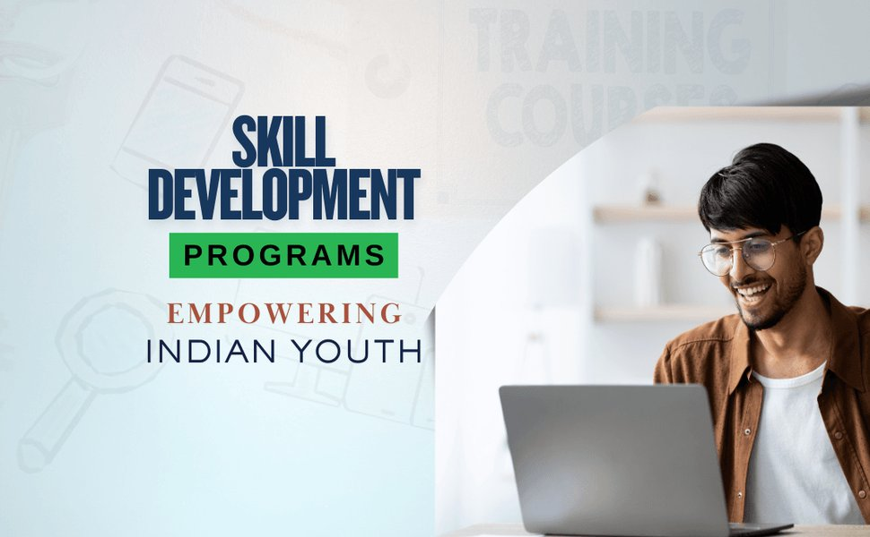
Government initiatives are heavily focused on youth skill development to boost employability.
Flagship Skill Training Programs
- Pradhan Mantri Kaushal Vikas Yojana (PMKVY): This is a pivotal scheme designed to mobilize and provide outcome-based skill training to a large number of Indian youth, making them employable and self-sufficient. It aims to bridge the skill gap and align training with industry requirements.
- Deen Dayal Upadhyaya Grameen Kaushalya Yojana (DDU-GKY): Specifically targeting rural youth, DDU-GKY provides skills and employment opportunities, often leading to regular monthly wages, thereby addressing rural unemployment and poverty.
- PM-SETU (Skill Enhancement & Training for Upskilling): Launched recently, this initiative focuses on upgrading Industrial Training Institutes (ITIs) to enhance skilling infrastructure and provide advanced training to millions of youth, preparing them for modern industries. This is part of broader 100-day employment drives.
Promoting Digital Literacy and Access
Initiatives like Digital India play a crucial role in improving digital access and literacy among the youth, which is essential for participation in the modern economy and for accessing online services and learning opportunities.

Fostering Entrepreneurship and Innovation
Cultivating a Startup Ecosystem for Young Innovators
Beyond traditional employment, the Indian government actively encourages entrepreneurship among its youth, viewing it as a key driver for job creation and economic diversification. Several schemes provide financial and infrastructural support for aspiring young entrepreneurs.
Key Entrepreneurial Support Schemes
- Startup India: This flagship initiative provides a conducive environment for startups, offering incentives, tax exemptions, and resources to foster innovation and business creation among young individuals.
- Pradhan Mantri Mudra Yojana (PMMY): PMMY is instrumental in providing financial assistance to micro and small enterprises, including those run by young entrepreneurs, by offering loans for business activities.
- Prime Minister's New Entrepreneurs Development Scheme: This scheme further supports young innovators by providing incubation and resources, helping them translate their ideas into viable businesses.

Holistic Development: Education, Health, and Leadership
Beyond Skills: Nurturing Well-Rounded Individuals
The government's approach extends beyond just skills and employment to encompass the overall well-being and development of young people, covering education, health, sports, and leadership roles.
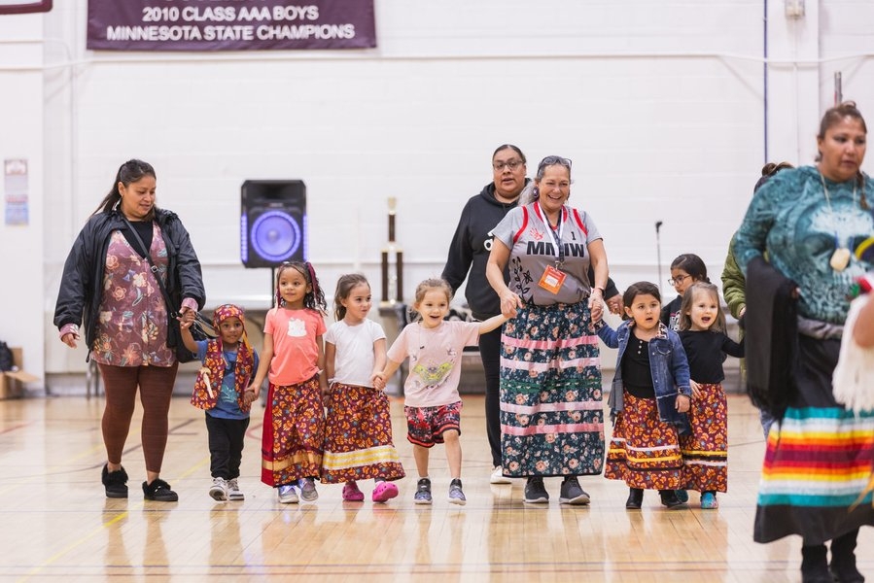
Education remains a critical focus for empowering Indian youth.
Educational and Social Empowerment Programs
- Mera Yuva Bharat (MY Bharat): Launched in 2023, this digital platform connects youth with various opportunities for volunteering, learning, and leadership across different sectors, promoting social mobility and practical skills.
- National Service Scheme (NSS) and National Youth Corps (NYC): These volunteer schemes engage disciplined youth in nation-building activities, community service, and promoting social harmony. NYC, for instance, amalgamates various volunteer programs and involves millions of youth annually.
- Adolescence Education Programme & National Programme for Youth and Adolescent Development (NPYAD): These programs focus on equipping young people with accurate information, life skills, substance abuse prevention, and gender sensitization, promoting healthy attitudes and personal development.
Promoting Sports and Physical Fitness
The Ministry of Youth Affairs and Sports spearheads initiatives to encourage sports and fitness among the youth:
- Khelo India: This program promotes grassroots sports infrastructure, identifies talent, and supports young athletes.
- Target Olympic Podium Scheme (TOPS): Aims to provide financial and logistical support to elite athletes, including young talent, to excel in international competitions.
- Sports Authority of India (SAI) & National Sports University: These institutions provide training and development facilities for aspiring athletes.
- Fit India Movement: Encourages youth wellness and a healthy lifestyle.

Financial Support and Welfare Schemes
Ensuring Access and Equity for All Youth
To ensure inclusivity, the government also implements various financial aid programs and welfare schemes, particularly targeting minority groups and those in need of assistance for education and skill development.
- Scholarships: Various scholarship programs are available to support youth in pursuing education and skill training.
- MUDRA Yojana: Beyond entrepreneurship, it facilitates loans for small businesses, many of which are youth-led.
- Schemes for Minority Youth Empowerment: Specific programs are designed to address the unique challenges faced by minority youth, ensuring their inclusion and participation in national development.
The Indian government has demonstrated a significant financial commitment to youth empowerment, with recent announcements of initiatives worth over Rs. 62,000 crore for skilling, entrepreneurial endeavors, and other youth-focused programs.

Understanding the Breadth of Youth Initiatives
A Visual Overview of India's Youth Empowerment Strategy
To better comprehend the multi-dimensional approach taken by the Indian government, the following radar chart illustrates the perceived strengths of various aspects of its youth empowerment programs based on comprehensive analysis.
Radar Chart: Perceived Strengths of India's Youth Empowerment Pillars (Scale 0-5)
The radar chart highlights that "Skill Development" and "Policy Framework" are areas of very strong government focus and perceived effectiveness, scoring 5. "Entrepreneurship," "Education," and "Leadership & Civic Engagement" also show strong emphasis and effectiveness with scores of 4. "Health & Sports," while important, appears to have a slightly lower relative focus compared to other areas, scoring 3, suggesting potential for further enhancement.

Impact and Future Directions
Realizing the Potential of Yuva Shakti
The cumulative effect of these government programs aims to empower India's youth, referred to as "Yuva Shakti," enabling them to take active and constructive roles in nation-building. By addressing skill gaps, creating employment opportunities, and fostering an environment for holistic growth, these initiatives seek to transform India's demographic advantage into a tangible force for progress.
India's Youth EmpowermentPolicy FrameworkNational Youth Policy (NYP)NYP 2014Draft NYP 2024Skill Development &EmploymentPradhan Mantri KaushalVikas YojanaDeen Dayal UpadhyayaGrameen Kaushalya YojanaPM-SETUDigital IndiaRozgar MelaEntrepreneurshipPromotionStartup IndiaPM Mudra YojanaPM New EntrepreneursDevelopment SchemeHolistic DevelopmentEducation & LearningScholarshipsAdolescence EducationProgrammeHealth & SportsKhelo IndiaTarget Olympic PodiumSchemeSports Authority of IndiaFit India MovementLeadership & CivicEngagementMera Yuva BharatNational Service Scheme(NSS)National Youth Corps (NYC)Nehru Yuva KendraSangathan (NYKS)National Programme forYouth & AdolescentDevelopmentFinancial SupportMUDRA Yojana LoansMinority YouthEmpowerment SchemesVision: Developed India by2047Youth Contribution toNation BuildingAddressing ChallengesUnemploymentSkill GapsSocial Inclusion
Mindmap: Interconnected Pillars of India's Youth Empowerment Programs
This mindmap illustrates the interconnectedness of various government initiatives, highlighting how different programs feed into the larger goals of skill development, entrepreneurship, and holistic youth development under the umbrella of the National Youth Policy. It portrays a comprehensive ecosystem designed to empower India's youth and leverage their potential for national progress.

Investment in Youth Initiatives: A Quantitative Look
Measuring Commitment Through Financial Allocations
The scale of the Indian government's commitment to youth empowerment can also be understood through the significant financial investments made in various schemes. The bar chart below provides an illustrative, opinionated breakdown of how government funds are allocated across different categories of youth programs.
Bar Chart: Estimated Government Funding Emphasis Across Youth Empowerment Categories (Scale 0-10)
This bar chart visually represents the strong emphasis placed on "Skill Training" and "Entrepreneurship Loans," which are assessed to receive the highest units of investment (9 and 8 respectively). "Educational Support" and "Digital Literacy" also show significant investment (7 each), followed by "Volunteer Programs" (6) and "Sports & Fitness" (5). This indicates a strategic allocation of resources primarily towards economic empowerment and foundational support for youth.

Understanding Key Youth Initiatives
A Concise Overview of Major Programs
The following table provides a concise overview of some of the most prominent government programs aimed at youth empowerment in India, categorized by their primary focus areas.
Category | Program/Scheme Name | Primary Objective
Policy & Vision | National Youth Policy (NYP) | Provides a comprehensive framework for youth development across various sectors.
Skill Development & Employment | Pradhan Mantri Kaushal Vikas Yojana (PMKVY) | Provides industry-relevant skill training for enhanced employability.
Skill Development & Employment | Deen Dayal Upadhyaya Grameen Kaushalya Yojana (DDU-GKY) | Skills and employment opportunities specifically for rural youth.
Skill Development & Employment | PM-SETU | Upgrades ITIs and boosts skilling for millions of youth.
Skill Development & Employment | Digital India | Improves digital access and literacy for all citizens, including youth.
Entrepreneurship | Startup India | Fosters innovation and business creation among youth.
Entrepreneurship | Pradhan Mantri Mudra Yojana (PMMY) | Provides financial assistance for small-scale enterprises and startups.
Entrepreneurship | Prime Minister's New Entrepreneurs Development Scheme | Supports young innovators with financial aid and incubation.
Civic Engagement & Leadership | Mera Yuva Bharat (MY Bharat) | Digital platform connecting youth with volunteering, learning, and leadership.
Civic Engagement & Leadership | National Service Scheme (NSS) | Engages youth in community service and nation-building activities.
Civic Engagement & Leadership | National Youth Corps (NYC) | Mobilizes youth volunteers for community service and social harmony.
Civic Engagement & Leadership | Nehru Yuva Kendra Sangathan (NYKS) | Promotes rural youth development through awareness and leadership.
Health & Sports | Khelo India | Promotes grassroots sports and talent identification.
Health & Sports | Target Olympic Podium Scheme (TOPS) | Supports elite athletes, including young talent, for international competitions.
Health & Sports | Fit India Movement | Encourages youth wellness and healthy lifestyles.

A Glimpse into Government's Vision for Youth
The "India's Youth: The Driving Force of Viksit Bharat" Perspective
The provided media includes a YouTube video titled "India's Youth: The Driving Force of Viksit Bharat," which encapsulates the government's perspective on the role of youth in achieving a developed India. This video highlights how the government is actively investing in the future of its largest youth population through education reforms, skill development initiatives, and other empowering programs.
The video "India's Youth: The Driving Force of Viksit Bharat" showcases the government's initiatives and vision for empowering young people.
This video underscores the government's strategic focus on transforming the demographic dividend into a tangible force for progress. It visually reinforces the commitment to youth empowerment through a narrative that links current policies and programs to the larger national aspiration of a "Viksit Bharat" (Developed India). The video serves as a public communication tool, emphasizing the importance of youth in India's journey towards becoming a global powerhouse.

Frequently Asked Questions (FAQ)
What is the National Youth Policy (NYP) in India?
How does the government support skill development for youth?
What initiatives promote youth entrepreneurship in India?
Are there programs for youth civic engagement and leadership?
How does the government address youth health and sports?

Conclusion
The Indian government has articulated a robust and dynamic strategy for youth empowerment, recognizing the critical role its young population plays in national development. Through comprehensive policy frameworks like the National Youth Policy, coupled with a diverse portfolio of schemes and programs, India is investing significantly in skill development, entrepreneurship, education, health, and civic engagement. Initiatives such as PMKVY, Startup India, Mera Yuva Bharat, and Khelo India collectively aim to equip young people with the necessary tools and opportunities to thrive, contribute to the economy, and participate actively in shaping the nation's future. While challenges in implementation may persist, the strategic intent and financial commitment underscore a clear vision to transform India's demographic dividend into a powerful force for a developed and inclusive nation by 2047.

Recommended Further Exploration
- How is the National Youth Policy 2024 shaping youth opportunities in India?
- What are the key impacts of Startup India on youth entrepreneurship?
- Examining the effectiveness of PMKVY in skill development and employment
- Role of youth volunteer programs like Mera Yuva Bharat in national development

Referenced Search Results
pmindia.gov.in
PM to unveil various youth-focused initiatives worth more than Rs 62,000 crore on 4th October - PM India
yas.nic.in
National Youth Corps | Government of India (MYAS)
mygov.in
Inviting Suggestions for National Youth Policy (NYP) Draft 2024 - MyGov
nyks.nic.in
National Programme for Youth and Adolescent Development (NPYAD) Guidelines - NYKS
pmwelfareschemetn.in
Schemes for Youth – PM Welfare Scheme
eshram.gov.in
Employment Schemes (eShram)
thecsrjournal.in
National Youth Day: Government Schemes Empower India Youth - The CSR Journal
static.pib.gov.in
100-day initiatives for skilling 20 lakh youth and job creation - PIB
popularschemes.com
Uttar Pradesh Swami Vivekananda Youth Empowerment Scheme | Govt ...
data.gov.in
Department of Youth Affairs
yas.nic.in
New Initiatives | Ministry of Youth Affairs and Sports
static.pib.gov.in
EMPOWERING AND NURTURING THE YUVA SHAKTI
bbc.com
Why India's Gen Z is not taking to the streets - BBC
afpr.in
Contemporary Government Initiatives for Youth Upliftment – Adhyayan ...
yas.gov.in
Home | Ministry of Youth Affairs and Sports | Government of India
mospi.gov.in
Youth in India- 2022 | Ministry of Statistics and Program ... - MoSPI
give.do
10 NGOs focused on empowering India's youth -
youngindia.foundation
Centre For Youth Policy - Young India Foundation
medium.com
National Youth Policy: A Decade of RADIO Silence and a Missed ...
yas.nic.in
National Programme for Youth and Adolescent Development | Ministry ...
data.gov.in
Youth Empowerment and Sports
pib.gov.in
National Youth Day 2025 - PIB
myscheme.gov.in
National Youth Corps
newsonair.gov.in
VP CP Radhakrishnan Calls on Students to Play Active Role in ...
india.gov.in
Youth| National Portal of India
yas.nic.in
POLICY | SCHEMES | PROGRAMMES
en.wikipedia.org
Youth empowerment - Wikipedia
dge.gov.in
Programmes of Government of India
mybharat.gov.in
Home | MYBharat

